**ConstantCurrentSupply_PNP**

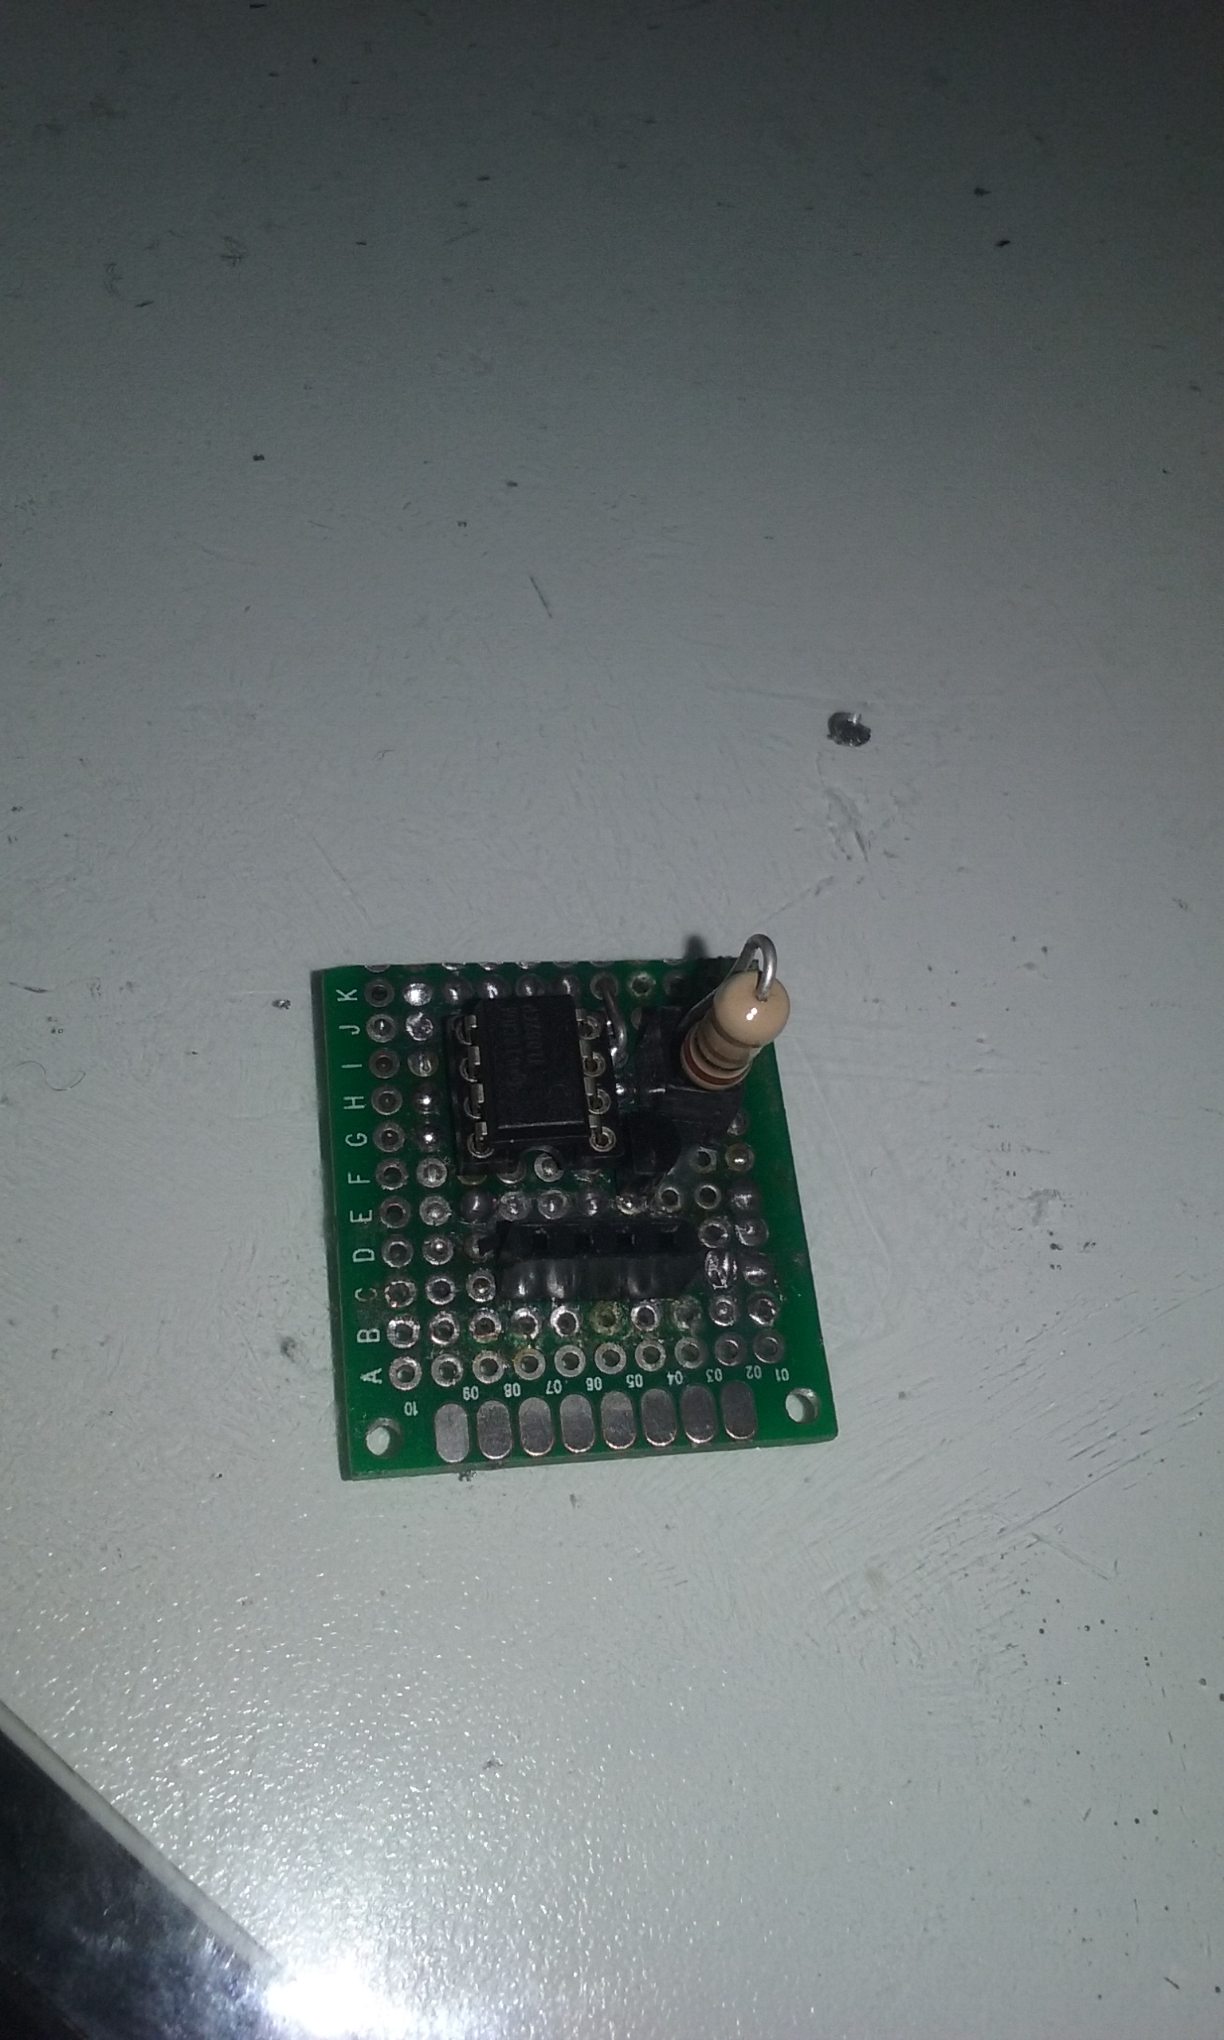

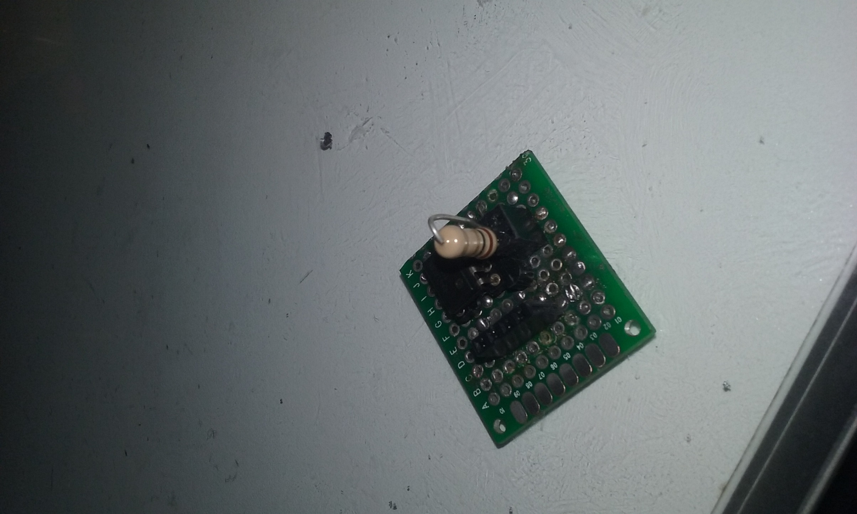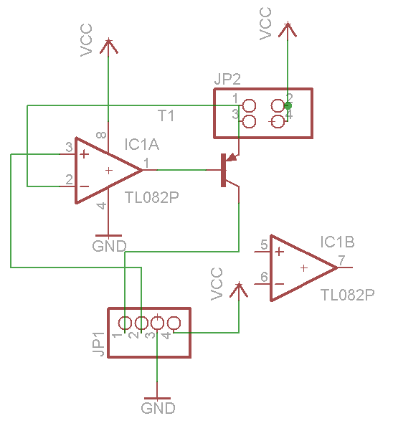

**Vcc**

**Collector**

**Vcc**

**GND**

**V+**

**Collector**

Use the 4-pin header to connect to a circuit.

The load should be connected to the pin-1 and ground, outside the board.

The (2x2)-pin header is for the sense resistor. One of the pins is connected to the PNP emissor and the other to Vcc.